[Cannot ping AWS EC2 instance [closed]](https://stackoverflow.com/questions/21981796/cannot-ping-aws-ec2-instance)

[\](https://stackoverflow.com/questions/ask)

I have an EC2 instance running in AWS. When I try to ping from my local box it is not available.

## First make sure the EC2 instance has a public IP.

If has a **Public DNS** or **Public IP** address (circled below) then you should be good. This will be the address you ping.

A few years late but hopefully this will help someone else...

## 1 - First make sure the EC2 instance has a public IP.

If has a **Public DNS** or **Public IP** address (circled below) then you should be good. This will be the address you ping. [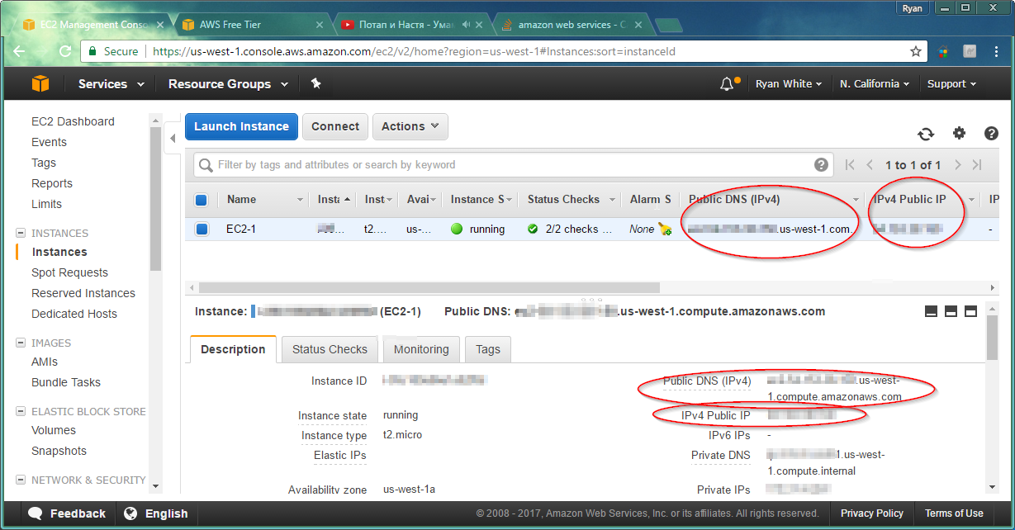](https://i.sstatic.net/yQjda.png)

## 2 - Amazon network rules

Next make sure the Amazon network rules allow Echo Requests. Go to the **Security Group** for the EC2.

* right click, select **inbound rules**
* A: select **Add Rule**
* B: Select **Custom ICMP Rule - IPv4**
* C: Select **Echo Request**
* D: Select either **Anywhere** or **My IP**
* E: Select **Save**

[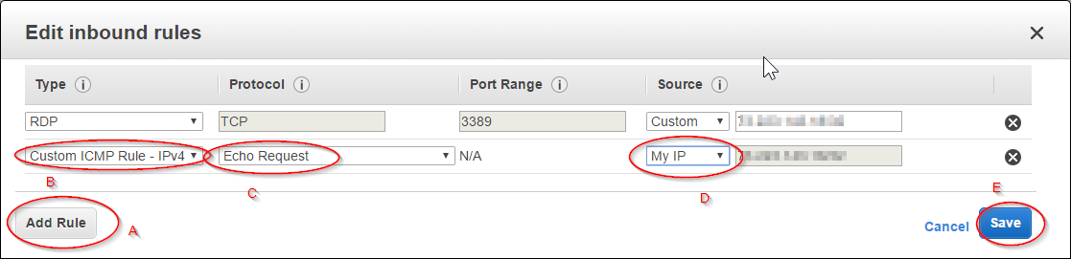](https://i.sstatic.net/yQjda.png)

## 3 - Access Control Lists (if applicable)

Note: Thank you **santosh s** for this one.

Your VPC is connected to a network and this network might have some ACLs blocking it also.

* A: Go to the **Your VPCs** --> **Default** --> **Network ACLs** --> **Details**(Tab) --> and select the **Main network ACL**. (it should bring you to Network ACLs with the network id filter applie[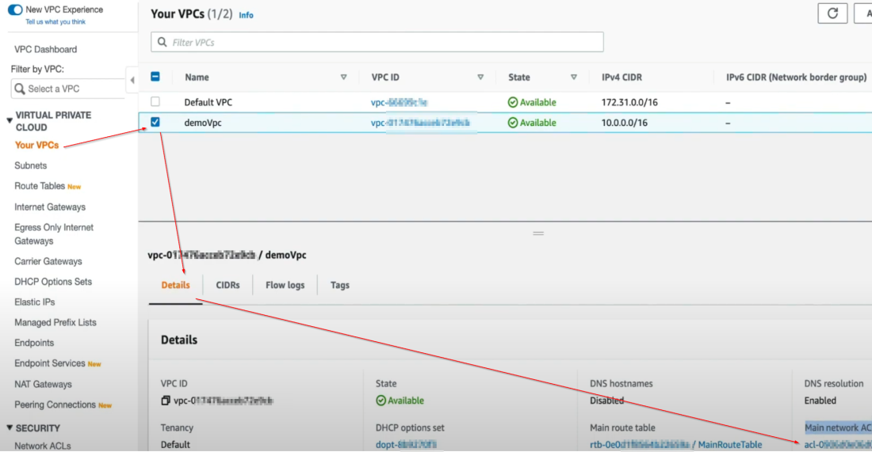](https://i.sstatic.net/Kd1pA.png)
* B: Then Select the **Network ACL ID** (screenshot not shown)
* C: Under **Inbound rules** tab, if the current rules don't already allow ICMP, then select **Edit Inbound Rule** --> **Add a New rule**

[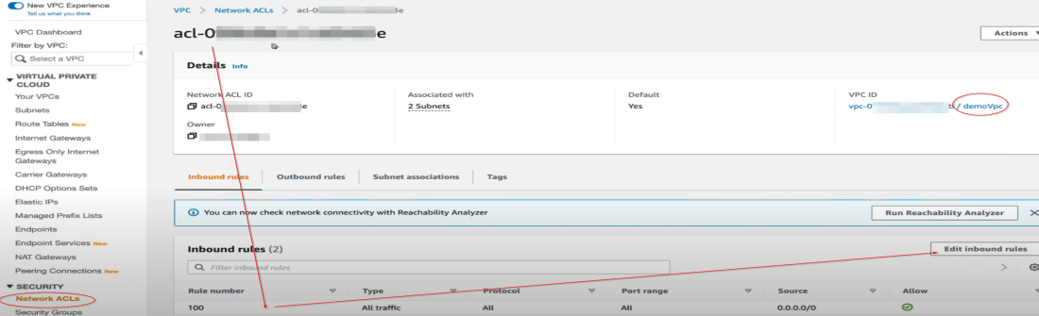](https://i.sstatic.net/8HPw6.png)

* D: Select **All ICMPs - IPv4**
* E: Select **Anywhere** or type another network CIDR
* F: Select **Allow** (0.0.0.0/0 is all)
* G: Select **Save Changes**
* H: do the same for **Outbound rules** tab (if needed)